
ENHANCING WEB BASED RECRUITMENT SYSTEM FOR EFFICIENT CANDIDATE SELECTION THROUGH RESUME SCREENING

RYAN MASHETI

SCT221-C004-0507/2022

SCHOOL OF COMPUTING AND INFORMATION TECHNOLOGY (SCIT)

SUPERVISOR
MR. VINCENT OMWOMA

‘A research project submitted to the Department of Information Technology in School of Computing and Information Technology for the requirement of Bachelors of Science in Information Technology at Jomo Kenyatta University of Agriculture and Technology.’

August 2026

DECLARATION
I declare that this project is my original work and has not been submitted to any other college or university for academic credit.

…………………. …………………
Signature Date

This project proposal has been submitted for examination with my approval as University Project Supervisor.

Mr. Vincent Omwoma ……………… ………………
Signature Date
ACKNOWLEDGEMENT
I would like to begin by sincerely thanking my supervisor for his guidance, patience and encouragement throughout this project. His wisdom shaped not only this work but also the way I think. I am deeply grateful to Jomo Kenyatta University of Agriculture and Technology for giving me the opportunity to undertake this project and for providing the facilities and resources needed to see it through. To my family and friends, thank you for standing by me for the constant encouragement, the understanding, and for putting up with my absence during the busiest periods. Your support meant more than I can put into words. Finally, to everyone who contributed to the completion of this project, directly or indirectly, thank you. This achievement is as much yours as it is mine.

ABSTRACT
This proposal presents a comprehensive framework for the development, implementation, and evaluation of a web based recruitment system for efficient candidate selection through resume screening designed to address the critical bottleneck of candidate screening in contemporary human resource management. The digital transformation of recruitment has democratized access to job opportunities, resulting in organizations receiving hundreds or thousands of applications for single positions-a volume that overwhelms traditional manual screening processes. This project proposes an integrated solution that combines the full administrative functionality of a modern applicant tracking system (ATS) with sophisticated, explainable artificial intelligence (AI) and natural language processing (NLP) capabilities for automated resume analysis and candidate ranking.
The proposed system adopts a three-tier architecture consisting of a React.js presentation layer, a Node.js/Express application layer, and a PostgreSQL data layer, augmented by a standalone AI microservice built with Python-based NLP libraries and transformer-based language models. This architectural separation of concerns enables independent scaling, maintenance, and development of each component, ensuring high availability, fault tolerance, and long-term adaptability. The resumel screening pipeline performs document ingestion, text preprocessing, named entity recognition, semantic analysis via word embeddings, and explainable candidate-job matching with confidence scores.
The project follows a rigorous mixed-methods research design combining quantitative performance metrics with qualitative user feedback, and an Agile/Scrum software development methodology organized into iterative two-week sprints. Evaluation will employ comparative analysis between AI-assisted and manual screening, statistical significance testing, user acceptance testing, and ongoing bias auditing. Expected outcomes include a fully functional recruitment platform, validated performance metrics demonstrating improved screening efficiency and accuracy, comprehensive technical and user documentation, and empirical contributions to the academic discourse on AI applications in human resource management.
TABLE OF CONTENTS
DECLARATION 1
ABSTRACT 3
LIST OF TABLES 8
LIST OF FIGURES 9
CHAPTER 1: INTRODUCTION 10
1.1 Background of the Project 10
1.2 Context of the Problem 11
1.3 Importance of the Project 11
1.4 Scope and Delimitations 13
CHAPTER 2: LITERATURE REVIEW 14
2.1 Traditional Recruitment Methods and Their Limitations 14
2.2 The Evolution of E-Recruitment and Web-Based Platforms 14
2.3 Artificial Intelligence in Human Resource Management 15
2.4 Natural Language Processing and Resume Analysis 16
2.5 Existing Commercial Recruitment Solutions 17
2.6 Gaps in Existing Research and Practice 19
CHAPTER 3: PROBLEM STATEMENT AND OBJECTIVES 21
3.1 Problem Statement 21
3.2 General Objective 22
3.3 Specific Objectives 22
3.4 Research Questions 23
CHAPTER 4: SYSTEM ARCHITECTURE AND DESIGN 24
4.1 Architectural Overview 24
4.2 Presentation Tier Design 24
4.3 Application Tier Design 25
4.4 Data Tier Design 25
4.5 AI Screening Microservice Design 26
4.6 Scalability and Fault Tolerance 27
Figure: System Architecture And Design 28
CHAPTER 5: METHODOLOGY AND IMPLEMENTATION APPROACH 29
5.1 Research Design and Approach 29
5.2 System Development Life Cycle 29
5.3 Requirements Gathering and Analysis 30
Figure: Use case diagram 31
5.4 Technologies and Tools 31
5.5 Implementation Phases 32
Figure: System Implementation Phases 33
5.6 User Interface Design 34
5.6.1 Login Page 34
5.6.2 Job listings / search page with filters 34
5.6.3 Resume upload page 35
5.6.4 Job posting form 35
5.6.5 Admin / user management page 36
5.6.6 Reports/analytics page 36
5.6.7 AI-ranked candidate shortlist 37
5.6.8 Explainability detail view 38
5.6.9 AI microservice JSON response 39
CHAPTER 6: SYSTEM REQUIREMENTS 40
6.1 Functional Requirements 40
6.2 Non-Functional Requirements 41
6.3 Hardware and Software Requirements 42
CHAPTER 7: TESTING, EVALUATION, AND VALIDATION 43
7.1 Testing Strategy 43
7.2 Data Collection and Analysis Methods 43
7.3 Key Performance Indicators 44
Table: Key Performance Indicators 44
7.4 Bias Monitoring and Fairness Evaluation 44
CHAPTER 8: PROJECT TIMELINE AND WORK PLAN 46
8.1 Development Phases 46
Table: Development Phases 46
8.2 Detailed Sprint Schedule 46
8.3 Budget 46
Table: Budget 46
CHAPTER 9: RISK ASSESSMENT 48
Table : Risk Assessment 48
CHAPTER 10: MONITORING AND EVALUATION PLAN 49
10.1 Monitoring Framework 49
10.2 Evaluation Methods 49
CHAPTER 11: EXPECTED OUTCOMES 50
11.1 System Deliverables 50
11.2 Academic and Practical Contributions 50
11.3 Benefits to Stakeholders 50
CHAPTER 12: CONCLUSION AND RECOMMENDATION 52
12.1 CONCLUSION 52
12.2 RECOMMENDATIONS 54
REFERENCES 55
APPENDICES 57

LIST OF TABLES
Table: Key Performance Indicators 37
Table: Development Phases 39
Table: Budget 39
Table : Risk Assessment 41

LIST OF FIGURES
Figure: System Architecture And Design 27
Figure: Use case diagram 30
Figure: System Implementation Phases 32
5.6.1 Login Page 33
5.6.2 Job listings / search page with filters 33
5.6.3 Resume upload page 34
5.6.4 Recruiter/admin side: Recruiter dashboard - stats cards 35
5.6.5 Job posting form 35
5.6.6 Admin / user management page 35
5.6.7 Reports/analytics page 36
5.6.8 AI-ranked candidate shortlist 36
5.6.9 Explainability detail view 36
5.6.10 AI microservice JSON response 36

CHAPTER 1: INTRODUCTION

1.1 Background of the Project
Recruitment remains one of the most critical functions within any organization, serving as the primary mechanism through which talent is identified, attracted, and integrated into the workforce. The quality of an organization's recruitment process directly influences its ability to acquire the human capital necessary for achieving strategic objectives and maintaining competitive advantage in an increasingly crowded marketplace. In contemporary organizational environments, where technological advancement and digital transformation are reshaping business operations across every sector, the recruitment function has undergone significant evolution from traditional paper-based processes to sophisticated digital platforms that leverage the power of the internet.
The emergence of web-based recruitment systems, often categorized under the broader umbrella of e-recruitment, has fundamentally altered the landscape of talent acquisition. These platforms enable organizations to transcend geographical limitations, reaching a broader and more diverse pool of candidates than was ever possible through traditional channels such as newspaper advertisements, job fairs, and word-of-mouth referrals. For job seekers, these systems offer unprecedented convenience, allowing them to browse opportunities, submit applications, and track their status from anywhere with an internet connection. For employers, web-based recruitment platforms provide centralized databases of candidate information, streamlined communication channels, and improved organizational capabilities that were previously unimaginable.
However, despite these considerable advancements, a critical bottleneck has persisted in the recruitment pipeline: the initial screening and shortlisting of candidates. When organizations receive hundreds or even thousands of applications for available positions, the task of reviewing each resume individually becomes a formidable challenge that can overwhelm even the most experienced human resource professionals. This bottleneck is not merely a matter of inconvenience or administrative burden; it represents a significant organizational inefficiency with measurable costs that extend throughout the entire hiring process and beyond.

1.2 Context of the Problem
The digital transformation of recruitment has created a paradoxical situation. On one hand, technology has made it easier than ever for job seekers to find and apply for positions, democratizing access to employment opportunities. On the other hand, this same accessibility has produced an overwhelming volume of applications that recruiters must process, often without adequate tools or support. The average corporate job posting now receives between 250 and 500 applications, with popular positions at well-known companies attracting thousands of candidates. This volume is simply impossible to manage effectively through manual processes.
Furthermore, the quality of applications varies widely. Some candidates are highly qualified and genuinely interested in the position, while others apply indiscriminately to dozens of positions regardless of their qualifications or interest level. This phenomenon, sometimes referred to as "resume spamming," further complicates the screening process and makes it more difficult for recruiters to identify the truly qualified candidates among the noise. Without automated tools to help filter and prioritize applications, recruiters are left to wade through this volume manually, often relying on crude shortcuts such as keyword scanning or rapid visual assessment.
The context of this problem is further complicated by the increasing emphasis on diversity, equity, and inclusion in the workplace. Organizations are under growing pressure to ensure that their hiring practices are fair and unbiased, yet manual screening processes are inherently susceptible to unconscious biases that can disadvantage candidates based on factors such as gender, ethnicity, age, educational background, or even the formatting of their resume. Research in cognitive psychology has documented numerous biases that affect human decision-making, including confirmation bias, affinity bias, halo effect, and anchoring bias, all of which can influence how recruiters evaluate candidates.

1.3 Importance of the Project
This project is important for several interconnected reasons that span practical, theoretical, and ethical dimensions. First and foremost, it addresses a genuine operational problem that affects organizations of all sizes and across all industries. The inefficiencies of manual resume screening are universal, and the benefits of intelligent automation are broadly applicable. Whether an organization is a small startup with a single HR professional or a large multinational corporation with a dedicated recruitment team, the challenge of screening candidates efficiently and accurately is a common concern that directly impacts organizational performance.
From a theoretical perspective, this project contributes to the growing body of academic knowledge regarding the practical application of artificial intelligence and natural language processing in human resource management. While much scholarly attention has been devoted to AI applications in fields such as finance, healthcare, marketing, and autonomous systems, the integration of these technologies into HR processes remains a relatively underexplored area. This project will provide empirical evidence regarding the effectiveness of AI-driven resume screening in a real-world recruitment context, thereby contributing to both academic understanding and practical implementation guidelines that can inform future research and development efforts.
Perhaps most importantly, this project has the potential to promote more equitable and inclusive hiring practices by reducing the influence of human biases in the initial screening phase. By evaluating candidates based on objective criteria derived from their qualifications, skills, and experience, rather than subjective impressions or demographic factors that may trigger unconscious bias, the system supports a more meritocratic approach to talent selection. This is not to suggest that AI is entirely free from bias, as AI systems can reflect and even amplify biases present in their training data. However, a well-designed AI screening system that is carefully validated, monitored, and adjusted can be more transparent and consistent than human decision-making, providing a foundation for fairer hiring practices.
Finally, this project represents an important step toward the future of work, where intelligent automation handles routine and repetitive tasks, freeing human professionals to focus on higher-value activities that require creativity, empathy, and strategic thinking. By automating the initial screening of resumes, the system allows recruiters to spend more time on meaningful interactions with candidates, conducting in-depth interviews, assessing cultural fit, and building relationships that contribute to long-term organizational success.

1.4 Scope and Delimitations
The scope of this project encompasses the complete design, development, testing, and evaluation of a web-based recruitment system with integrated AI-driven resume screening capabilities. The system will support the full recruitment workflow from job posting and application submission through AI-powered analysis and candidate ranking. It will serve both job seekers and recruiters through a unified, responsive web platform.
However, the project has defined boundaries. The system will not conduct personality assessments, video interviews, or psychometric evaluations, as these are complex domains requiring specialized expertise outside the current scope. The system will not verify the authenticity of uploaded resumes or credentials, meaning screening accuracy depends on the accuracy of candidate-provided information. Additionally, the AI module will rely primarily on text-based data, meaning non-textual elements such as resume design and visual presentation will not influence screening outcomes. The system will also not integrate with third-party job platforms or social media networks in the current scope, though the API architecture will be designed to facilitate such future integrations.

CHAPTER 2: LITERATURE REVIEW

2.1 Traditional Recruitment Methods and Their Limitations
Before the advent of digital technologies, recruitment was predominantly conducted through traditional channels such as newspaper advertisements, physical job boards, employment agencies, and word-of-mouth referrals. These methods, while effective in their time, were inherently limited in their reach and efficiency. Organizations could only attract candidates within their immediate geographic area or through the networks of their existing employees. The screening process was entirely manual, with HR professionals reviewing paper applications and making decisions based on their personal experience and judgment. While this approach allowed for a degree of personal connection that is sometimes lacking in digital processes, it was also slow, expensive, and prone to the same biases and inconsistencies that plague modern manual screening.
Research by Barber (1998) and others has documented the resource-intensive nature of traditional recruitment, noting that the costs of advertising, processing applications, and conducting interviews could consume a significant portion of an organization's HR budget. Furthermore, the limited reach of traditional methods meant that organizations often struggled to find candidates with the specific skills and qualifications they needed, particularly for specialized or technical positions. The transition to digital recruitment, beginning in the 1990s, was driven by a desire to overcome these limitations and access a broader, more diverse talent pool.

2.2 The Evolution of E-Recruitment and Web-Based Platforms
The emergence of the internet in the 1990s brought about a fundamental transformation in recruitment practices, giving rise to what is now known as e-recruitment. Early online job boards such as Monster and CareerBuilder, launched in the mid-1990s, provided a centralized platform where employers could post job openings and job seekers could search for opportunities. These platforms represented a significant improvement over traditional methods, offering greater reach, lower costs, and faster communication. However, they were still relatively simple in their functionality, essentially serving as digital classified advertisements rather than integrated recruitment solutions.
As internet technologies advanced, e-recruitment evolved into a more sophisticated ecosystem. The development of applicant tracking systems (ATS) in the early 2000s marked a major step forward, providing organizations with tools to manage the entire recruitment process from a single platform. According to Parry and Tyson (2008), the adoption of online recruitment methods in the United Kingdom grew rapidly throughout the 2000s, driven by the convenience and cost-effectiveness of digital platforms. Their analysis found that organizations using online recruitment were able to reach larger candidate pools while reducing the administrative burden associated with paper-based processes.
Gus Dorf (2008) emphasized that recruitment and selection are among the most critical functions of human resource management, as the quality of an organization's workforce directly determines its capacity to achieve strategic objectives. Their work highlighted the importance of developing systematic, efficient, and fair recruitment processes, noting that technology could play a significant role in achieving these goals. However, they also cautioned that technology alone cannot solve all recruitment challenges, and that human judgment remains essential for assessing cultural fit, interpersonal skills, and other qualities that are difficult to quantify.
More recent studies have documented the continued growth and sophistication of web-based recruitment platforms. Breaugh (2017) observed that modern recruitment systems have become increasingly integrated with other HR technologies, including onboarding platforms, learning management systems, and workforce analytics tools. This integration has created a more seamless experience for both candidates and recruiters, but it has also raised concerns about data privacy, algorithmic bias, and the potential for technology to depersonalize the recruitment process.

2.3 Artificial Intelligence in Human Resource Management
Artificial intelligence has emerged as one of the most transformative technologies of the twenty-first century, with applications spanning virtually every industry and domain. In human resource management, AI has been applied to a wide range of functions, including talent acquisition, performance management, employee engagement, workforce planning, and learning and development. The potential of AI to automate routine tasks, analyze large volumes of data, and generate insights that inform strategic decisions has generated significant interest among HR professionals and researchers alike.
The application of AI to recruitment, in particular, has attracted considerable attention. Tambe et al. (2019) conducted a comprehensive study of AI adoption in HR departments and found that recruitment was one of the most common areas for AI implementation. They identified several factors driving this trend, including the volume of data generated by recruitment processes, the repetitive nature of many recruitment tasks, and the potential for AI to improve the efficiency and objectivity of candidate evaluation. Their research also highlighted significant challenges, including concerns about algorithmic bias, the need for transparency in AI decision-making, and the importance of maintaining human oversight in the hiring process.
Raghavendra (2019) explored the potential of AI to transform HR practices, arguing that AI could enhance decision-making, improve employee experiences, and enable more strategic workforce planning. However, they also noted that the adoption of AI in HR is not without risks, particularly when algorithms are trained on biased data or when their decision-making processes are opaque and difficult to explain. The concept of "algorithmic fairness" has emerged as a critical area of research, with scholars and practitioners seeking to understand how AI systems can be designed and deployed in ways that minimize discrimination and promote equity.

2.4 Natural Language Processing and Resume Analysis
Natural language processing (NLP) is a branch of artificial intelligence that focuses on the interaction between computers and human language. NLP techniques enable computers to read, understand, and generate human language in a way that is meaningful and useful. The application of NLP to resume analysis is particularly relevant because resumes are unstructured documents written in natural language, with significant variation in format, terminology, and organization. Effective resume analysis requires the ability to parse complex text, identify relevant information, and understand the semantic relationships between different pieces of information.
Several NLP techniques have been applied to resume parsing and analysis. Named Entity Recognition (NER) is used to identify and extract structured information from unstructured text, such as names, organizations, dates, skills, and qualifications. Dependency parsing and part-of-speech tagging help to understand the grammatical structure of sentences and the relationships between words. Word embeddings and semantic similarity analysis enable the comparison of words and phrases based on their meaning rather than their exact lexical form, allowing the system to recognize that "Python developer" and "Python programmer" refer to similar skills.
Machine learning approaches, including supervised classification, clustering, and deep learning, have also been applied to resume analysis. These techniques can be trained on large datasets of resumes and job descriptions to learn patterns that distinguish qualified candidates from unqualified ones. Singh and Sharma (2020) reviewed various machine learning approaches to resume screening and found that ensemble methods combining multiple algorithms often achieved the best results. They also noted that the quality and diversity of training data were critical factors in determining the performance of these systems, and that models trained on biased data could perpetuate or even amplify existing biases in the hiring process.

2.5 Existing Commercial Recruitment Solutions
The commercial market for AI-enhanced recruitment tools has grown rapidly in recent years, with numerous vendors offering solutions that claim to improve various aspects of the hiring process. LinkedIn Talent Solutions uses machine learning algorithms to recommend candidates based on their profile data, activity on the platform, and similarity to other successful hires. The platform also provides tools for recruiters to search for candidates using natural language queries and to automate outreach campaigns. While these features are powerful, they are primarily focused on sourcing and outreach rather than comprehensive resume screening and evaluation.
HireVue has taken a different approach, applying AI to video interviews to analyze candidate responses, facial expressions, and vocal patterns. The platform claims to assess factors such as communication skills, enthusiasm, and cultural fit based on these analyses. However, this approach has been controversial, with critics raising concerns about the validity of facial expression analysis, the potential for bias against candidates from different cultural backgrounds, and the lack of transparency in the algorithm's decision-making process. Several studies have questioned whether the claims made by HireVue and similar platforms are supported by rigorous empirical evidence.
Other platforms such as Pymetrics use gamified assessments and neuroscience-based AI to evaluate candidate fit. Candidates play a series of short games that are designed to measure cognitive and emotional traits, and the AI compares their performance profiles against those of successful employees in the target role. While this approach is innovative and potentially valuable, it is not directly applicable to resume screening and may not capture the full range of qualifications and experience that candidates bring to a position. Similarly, Textio focuses on optimizing job descriptions using AI to improve inclusivity and engagement, which is a valuable contribution but does not address the screening challenge.
What becomes clear from this review of existing solutions is that while many vendors offer AI-enhanced tools for specific aspects of recruitment, there is a notable gap in the market for a comprehensive, integrated platform that combines the full administrative functionality of an applicant tracking system with sophisticated, validated AI-powered resume screening. Most existing solutions either focus on one aspect of recruitment or are designed for large enterprises with substantial budgets and technical resources. Small and medium-sized organizations, which represent the majority of employers globally, are often unable to access these advanced tools.

2.6 Gaps in Existing Research and Practice
Despite the growing interest in AI-enhanced recruitment, several significant gaps remain in both academic research and industry practice. First, there is a lack of rigorous, empirically validated studies comparing the effectiveness of AI-driven screening with manual screening in real-world recruitment contexts. Many of the claims made by commercial vendors are based on proprietary data and methodologies that have not been independently verified. Academic studies that have examined AI in recruitment have often focused on specific aspects, such as bias detection or algorithmic transparency, without providing a comprehensive evaluation of the entire screening process.
Second, there is insufficient attention to the explainability and interpretability of AI screening decisions. Recruiters and hiring managers need to understand why a particular candidate was ranked highly or poorly by the system, both to make informed decisions and to ensure compliance with employment law and anti-discrimination regulations. Many existing AI systems operate as "black boxes," making decisions that are difficult or impossible to explain. This lack of transparency undermines trust in the system and creates legal and ethical risks for organizations that use these tools.
Third, the issue of bias in AI recruitment systems remains a significant concern that has not been adequately addressed. While AI has the potential to reduce human bias, it can also introduce or amplify algorithmic bias if the training data contains historical patterns of discrimination. Research by Dastin (2018) and others has documented cases where AI recruitment tools have discriminated against women, minorities, and other protected groups. Addressing this issue requires careful attention to data collection, model validation, and ongoing monitoring of system outcomes to detect and correct bias.
Fourth, there is a need for recruitment systems that are accessible to organizations of all sizes, not just large enterprises with substantial budgets. The development of affordable, user-friendly AI-enhanced recruitment platforms would democratize access to these technologies and enable smaller organizations to compete more effectively in the talent market. This project addresses these gaps by developing a comprehensive, integrated, and validated AI-enhanced recruitment system that is designed with transparency, fairness, and accessibility in mind.

CHAPTER 3: PROBLEM STATEMENT AND OBJECTIVES

3.1 Problem Statement
The growth of web-based recruitment has made it easier for organizations to advertise vacancies and receive applications from a wider pool of candidates. However, this has also created a major challenge: recruiters often receive hundreds or even thousands of applications for a single position, making manual resume screening slow, time-consuming, and inconsistent.

Recruiters are required to review resumes, compare applicants against job requirements, and identify the most suitable candidates within limited timeframes. As the number of applications increases, manual screening becomes impractical. Consequently, recruiters often rely on quick keyword searches or brief resume scans, increasing the likelihood of overlooking qualified candidates whose skills may be described differently or presented in non-standard formats. Manual evaluation is also susceptible to inconsistencies and unconscious bias, resulting in unfair hiring decisions and reduced recruitment quality.

Although Applicant Tracking Systems (ATS) help organizations manage applications, many focus primarily on administrative tasks such as storing resumes and tracking candidate progress rather than intelligently evaluating candidate qualifications. Existing AI-powered recruitment platforms provide more advanced screening capabilities, but they are often expensive and too complex for small and medium-sized enterprises (SMEs), limiting their accessibility.

These challenges lead to delayed hiring, increased recruitment costs, vacant positions, and the possibility of losing highly qualified candidates to competing organizations. Inefficient screening also affects workforce diversity and fairness by allowing subjective judgment to influence hiring decisions.

To address these challenges, this project proposes the development of an AI-enhanced web-based recruitment system that automatically analyzes, evaluates, and ranks candidates based on their qualifications and job requirements using Artificial Intelligence (AI) and Natural Language Processing (NLP). The proposed system aims to reduce screening time, improve the consistency and accuracy of candidate selection, and provide an affordable recruitment solution that supports fair and efficient hiring for organizations of different sizes.

3.2 General Objective
The general objective of this project is to develop, implement, and evaluate an AI-enhanced web-based recruitment system that significantly improves the efficiency, accuracy, and fairness of candidate screening and selection processes within organizations. The system aims to serve as a comprehensive recruitment platform that integrates the administrative capabilities of modern applicant tracking systems with advanced artificial intelligence and natural language processing capabilities for automated resume analysis and candidate ranking.

3.3 Specific Objectives
To achieve the general objective, this project will pursue the following specific, measurable, and time-bound objectives:
- Analysis & Research: To analyze existing web-based recruitment systems, identify critical limitations in their candidate screening processes, and evaluate suitable AI and natural language processing techniques for automated resume analysis.
- Design: To design a comprehensive, scalable system architecture that integrates web-based recruitment functionality with AI-driven resume evaluation capabilities, ensuring usability, security, and performance.
- Implementation: To implement the proposed system using modern web technologies and AI tools, developing a robust candidate ranking algorithm and an intuitive interface for both job seekers and recruiters.
- Testing, Evaluation & Documentation: To test and validate the effectiveness of the automated screening feature through rigorous comparative analysis, evaluate system impact on recruitment efficiency and fairness, and produce comprehensive documentation and training materials.

3.4 Research Questions
This project is guided by the following research questions, which have been formulated to address the core challenges and evaluate the proposed solution systematically:
- What are the key limitations of existing web-based recruitment systems in terms of candidate screening efficiency, accuracy, and consistency, and how do these limitations affect organizational hiring outcomes?
- Which artificial intelligence and natural language processing techniques are most effective for analyzing resume content, extracting relevant information, and matching candidate qualifications to job requirements?
- How can an AI-enhanced recruitment system be designed and implemented to minimize unconscious bias while maintaining or improving screening accuracy compared to traditional manual methods?
- What is the comparative effectiveness of AI-driven resume screening versus manual screening in terms of time efficiency, candidate quality, and consistency of evaluation?
- What are the key usability, trust, and adoption factors that influence HR professionals' willingness to integrate AI-enhanced screening into their recruitment workflows?

CHAPTER 4: SYSTEM ARCHITECTURE AND DESIGN

4.1 Architectural Overview
The core architecture of the proposed system is a three-tier web application augmented with a separate AI microservice. This design pattern separates the system into distinct layers-presentation, application, and data-each of which can be developed, deployed, and scaled independently. This separation of concerns is a well-established best practice in software engineering that maximizes maintainability, scalability, and reliability.
In this model, the presentation tier is a responsive React.js web application that provides an intuitive interface for job seekers to submit resumes and for recruiters to post jobs and view AI-ranked candidates. The application tier consists of a Node.js server using the Express framework, handling business logic, user authentication, session management, and interactions with the AI service. The data tier uses PostgreSQL for structured data (users, jobs, applications) and may incorporate a document database to index resume text. All client-server communication goes through the application tier; the presentation and data tiers do not interact directly, ensuring security and maintainability.
The AI screening module is implemented as a standalone microservice. It exposes a RESTful API: recruiters' resumes and job descriptions are submitted as input, and the service returns a ranked list of candidates with scored matches. By making it a separate service, we achieve independent scaling and maintenance. As one source notes, robust deployments treat the screening model as a microservice with clear I/O schemas. In practice, this means we can update or swap out the AI model without redeploying the entire application, and we can allocate extra resources to it if needed.

4.2 Presentation Tier Design
The presentation tier is a responsive web application built in React.js with TypeScript. React is widely used for building user interfaces and provides a component-based architecture where UI elements are built from reusable components. This modularity makes development efficient and maintainable. The frontend will use React Router for page navigation and a component library such as Material-UI for consistent, accessible design.
For job seekers, the interface provides a clean, intuitive experience for creating profiles, uploading resumes, searching for jobs, and submitting applications. The resume upload process includes clear instructions and validation to ensure that uploaded files are in supported formats and contain the necessary information. For recruiters, the interface provides a comprehensive dashboard with features for posting jobs, managing applications, reviewing AI-generated rankings, and communicating with candidates. The ranking interface presents candidates in a clear, sortable format with visual indicators of relevance scores and detailed explanations of the ranking criteria.
The interface design follows user-centered design principles, with a focus on usability, accessibility, and aesthetics. The design process includes the creation of wireframes, mockups, and interactive prototypes that will be tested with representative users before implementation. The interface is responsive, ensuring that it works well on desktop computers, tablets, and mobile devices, and complies with WCAG 2.1 Level AA accessibility standards.

4.3 Application Tier Design
The application tier is implemented as a RESTful API using Node.js with the Express framework. Node.js is a cross-platform, open-source JavaScript runtime environment that excels at handling web requests. Express organizes the server's business logic, handling tasks like user authentication, session management, and calling external services.
The backend implements RESTful APIs for all functionality, including job CRUD operations, user authentication, and AI service calls. Authentication will be implemented using Passport.js or similar middleware, supporting secure password hashing and role-based access control. The application tier acts as a controlled gateway between the presentation and data tiers, enforcing security policies and business rules before any data is accessed or modified.

4.4 Data Tier Design
The data tier uses PostgreSQL as the primary relational database management system. PostgreSQL is a powerful, open-source object-relational database system known for reliability, feature robustness, and performance. It supports advanced features such as joins, transactions, and full-text search, which are essential for the recruitment system's relational data model.
The database schema will be normalized to third normal form (3NF) to minimize redundancy and ensure data integrity. Key entities include users (job seekers and recruiters), organizations, job postings, applications, resumes, screening results, and system logs. Relationships include one-to-many relationships between organizations and job postings, between job postings and applications, and between users and applications.
In addition to PostgreSQL, the system may use a document store or search engine such as Elasticsearch for full-text indexing of resume content. This enables efficient searching and filtering of candidates based on skills, experience, and other criteria. The search engine will be integrated with the AI screening module to provide fast, relevant results for recruiter queries.

4.5 AI Screening Microservice Design
The AI screening module is the distinguishing feature of this system. It is designed as a standalone microservice that can be developed, deployed, and scaled independently of the main application. This microservice architecture provides several advantages: it allows the AI module to be updated or replaced without affecting the rest of the system, it enables the AI module to be scaled independently based on demand, and it supports the integration of different AI models or services as the technology evolves.
The AI microservice exposes a RESTful API that accepts resume documents and job descriptions as input and returns structured analysis results and candidate rankings. The core pipeline consists of several stages:
- Document Ingestion and Preprocessing: Uploaded resumes are parsed and converted to plain text, with support for multiple formats including PDF, DOCX, and TXT. The text is cleaned, tokenized, and normalized to prepare it for analysis.
- Information Extraction: Named Entity Recognition (NER) models identify and extract structured information from the resume text, including personal details, education history, work experience, skills, certifications, and other relevant entities. The system uses a combination of rule-based extraction and machine learning-based NER models trained on annotated resume datasets.
- Semantic Analysis: Word embeddings and transformer-based language models (such as BERT or its variants) understand the meaning of the extracted information and identify relationships between different entities. This allows the system to recognize semantic equivalence between different phrasings of the same skill or qualification.
- Candidate-Job Matching: The system compares extracted information from the resume against the requirements specified in the job description. Semantic similarity analysis matches skills and qualifications even when they are expressed using different terminology. For example, the system recognizes that "proficient in Python programming" and "experienced Python developer" refer to the same underlying skill.
- Ranking Generation: The matching algorithm generates a relevance score for each candidate based on the degree of alignment between their qualifications and the job requirements. Candidates are ranked accordingly, with the highest-scoring candidates appearing at the top of the recruiter's shortlist.
- Explainability and Transparency: To ensure explainability, the system provides detailed explanations for each ranking decision. Recruiters can see which requirements the candidate meets, which they partially meet, and which they do not meet, along with confidence scores for each assessment. This explainability is essential for building trust in the system and for ensuring compliance with anti-discrimination regulations that require employers to justify their hiring decisions.

4.6 Scalability and Fault Tolerance
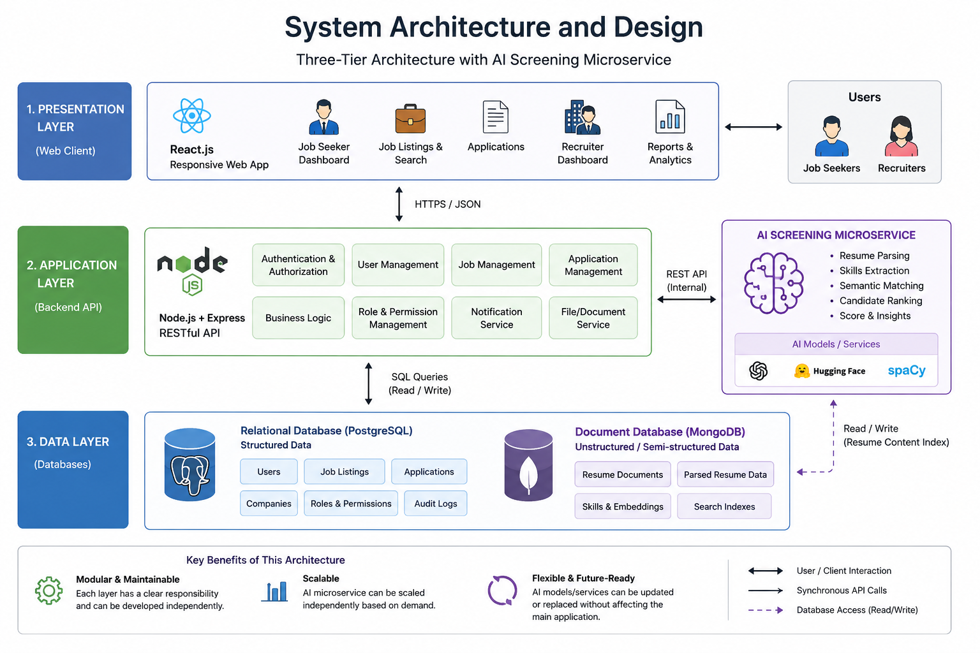
This overall architecture offers high scalability and reliability. Each component can scale independently to meet demand. If the AI service experiences high load (e.g., batch screening many resumes), it can be scaled up without affecting the main web app. Conversely, if one component fails (such as a brief outage of the AI service), fault isolation in microservices design means the rest of the application can continue operating. These design choices result in a flexible, maintainable system that separates concerns cleanly.

Figure: System Architecture And Design

CHAPTER 5: METHODOLOGY AND IMPLEMENTATION APPROACH

5.1 Research Design and Approach
This project adopts a mixed-methods research design that combines quantitative and qualitative approaches to address the research questions and evaluate the proposed system. The quantitative component involves the measurement of system performance metrics such as screening accuracy, processing time, and consistency of rankings. The qualitative component involves the collection of user feedback, experiences, and perceptions through interviews and surveys. This mixed-methods approach is appropriate because it allows for a comprehensive evaluation that captures both the technical performance of the system and the human factors that influence its adoption and effectiveness.
The research will be conducted within a pragmatic paradigm that prioritizes practical outcomes and problem-solving over adherence to a single philosophical position. This pragmatic approach is well-suited to applied research projects such as this one, where the primary goal is to develop a practical solution to a real-world problem while also contributing to theoretical knowledge. The research will follow a systematic process that includes requirements analysis, system design, development, testing, and evaluation, with each stage informed by the findings of the previous stage.

5.2 System Development Life Cycle
The system will be developed following an Agile software development methodology, specifically the Scrum framework, which is well-suited to projects that involve complex requirements, uncertain technologies, and the need for iterative refinement. The development process will be organized into two-week sprints, with each sprint delivering a potentially shippable increment of the system. At the end of each sprint, the development team will conduct a sprint review to demonstrate progress to stakeholders and a sprint retrospective to identify opportunities for process improvement.
The Agile approach is particularly appropriate for this project because it allows for flexibility in responding to new insights about AI and NLP technologies that may emerge during the development process. AI model development is inherently experimental, and the ability to iterate quickly based on feedback from testing is essential. The Scrum framework provides structure for this iterative process while maintaining focus on delivering value to stakeholders at each stage of development.

5.3 Requirements Gathering and Analysis
The requirements gathering phase will employ multiple techniques to ensure a comprehensive understanding of stakeholder needs. These techniques will include structured interviews with HR professionals and hiring managers, questionnaires distributed to job seekers and recruiters, observation of existing recruitment workflows, and analysis of existing systems and documentation. The requirements will be categorized as functional requirements (what the system must do) and non-functional requirements (how the system must perform), and will be documented using use case diagrams, user stories, and requirement specification documents.
Stakeholder analysis will be conducted to identify all parties affected by the system, including job seekers, recruiters, hiring managers, HR administrators, system administrators, and organizational leadership. The needs and expectations of each stakeholder group will be documented and prioritized using the MoSCoW method (Must have, Should have, Could have, Won't have). This prioritization will guide the development process, ensuring that the most critical features are delivered first and that resources are allocated efficiently.

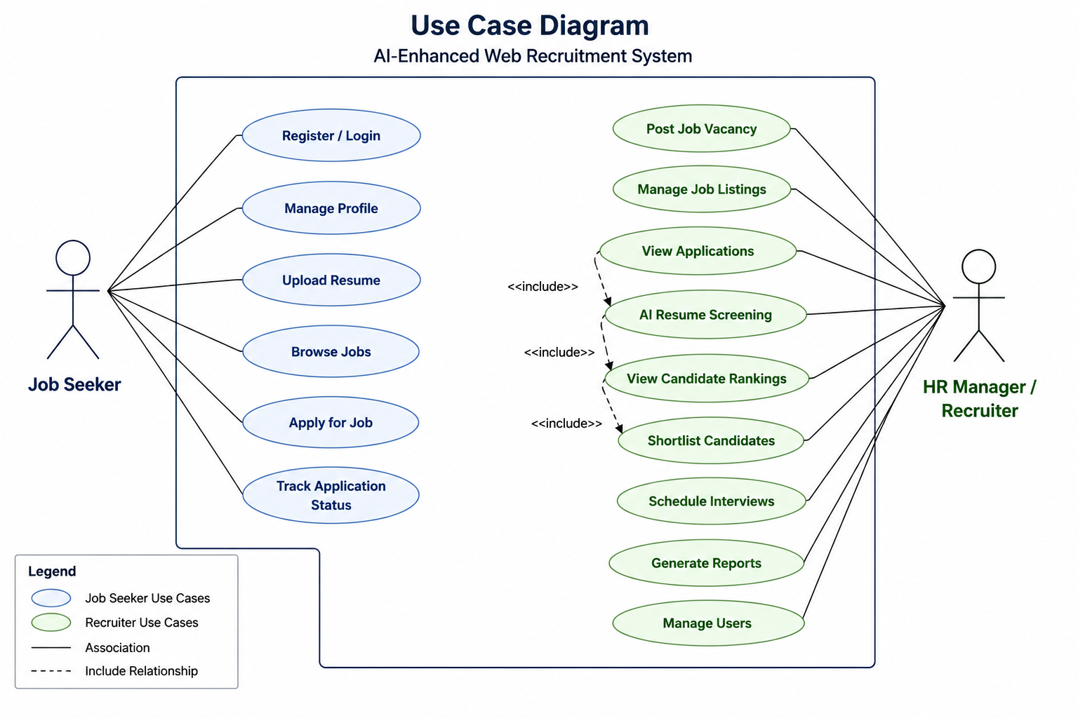

Figure: Use case diagram

5.4 Technologies and Tools
The development of the system will utilize a carefully selected set of tools and technologies that balance capability, maintainability, and cost-effectiveness:
- Frontend: React.js with TypeScript, providing a modern, type-safe development experience. React Router for navigation and Material-UI for consistent component design.
- Backend API: Node.js with Express, chosen for its performance, scalability, and the ability to share code between frontend and backend.
- Database: PostgreSQL, a robust, open-source relational database with excellent support for complex queries and full-text search.
- AI and NLP: Python with spaCy for natural language processing tasks, and scikit-learn or TensorFlow for machine learning models. Pre-trained language models such as BERT or its variants may be fine-tuned for the specific task of resume analysis.
- AI Microservice Deployment: Containerized using Docker and deployed to a cloud platform such as AWS, Google Cloud, or Azure, with Kubernetes used for orchestration and scaling.
- Version Control and CI/CD: Git for version control, and GitHub Actions or similar tools for continuous integration and continuous deployment pipelines.

5.5 Implementation Phases
The implementation will follow a structured iterative SDLC model:
- Requirement Analysis: Gather requirements from mock stakeholders and refine user stories. Sketch UML diagrams and data models.
- System Design: Finalize the three-tier plus microservice architecture. Create ER diagrams for the database and sequence diagrams for key workflows (e.g., how a resume gets processed).
- Implementation: Code is written in small, testable units. First implement the user login flow, then job posting features, and then integrate the AI service calls.
- Testing: Unit tests verify individual modules (e.g., the resume parser outputs correct JSON). Integration tests ensure end-to-end flows (user applies to job and sees results). User acceptance testing with volunteers simulating job seekers and recruiters.
- Deployment and Evaluation: Deploy on a cloud VM or local network for a pilot test. Evaluate system performance (page load times, resume processing time) and screening accuracy (compare AI rankings against expert-curated shortlists).
- Iteration: Based on tests, return to earlier stages to adjust the AI model or database indices to improve performance.

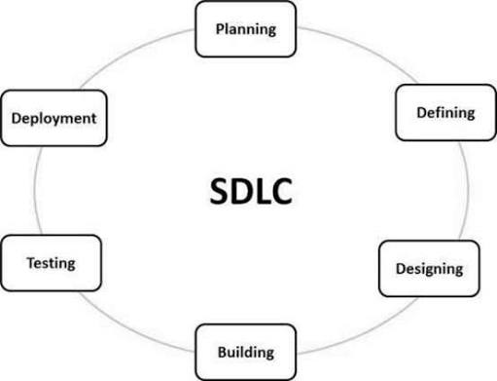
Figure: System Implementation Phases

5.6 User Interface Design
These interfaces demonstrate the different interactions users actively perform on HoraiLabs.

5.6.1 Login Page


5.6.2 Job listings / search page with filters
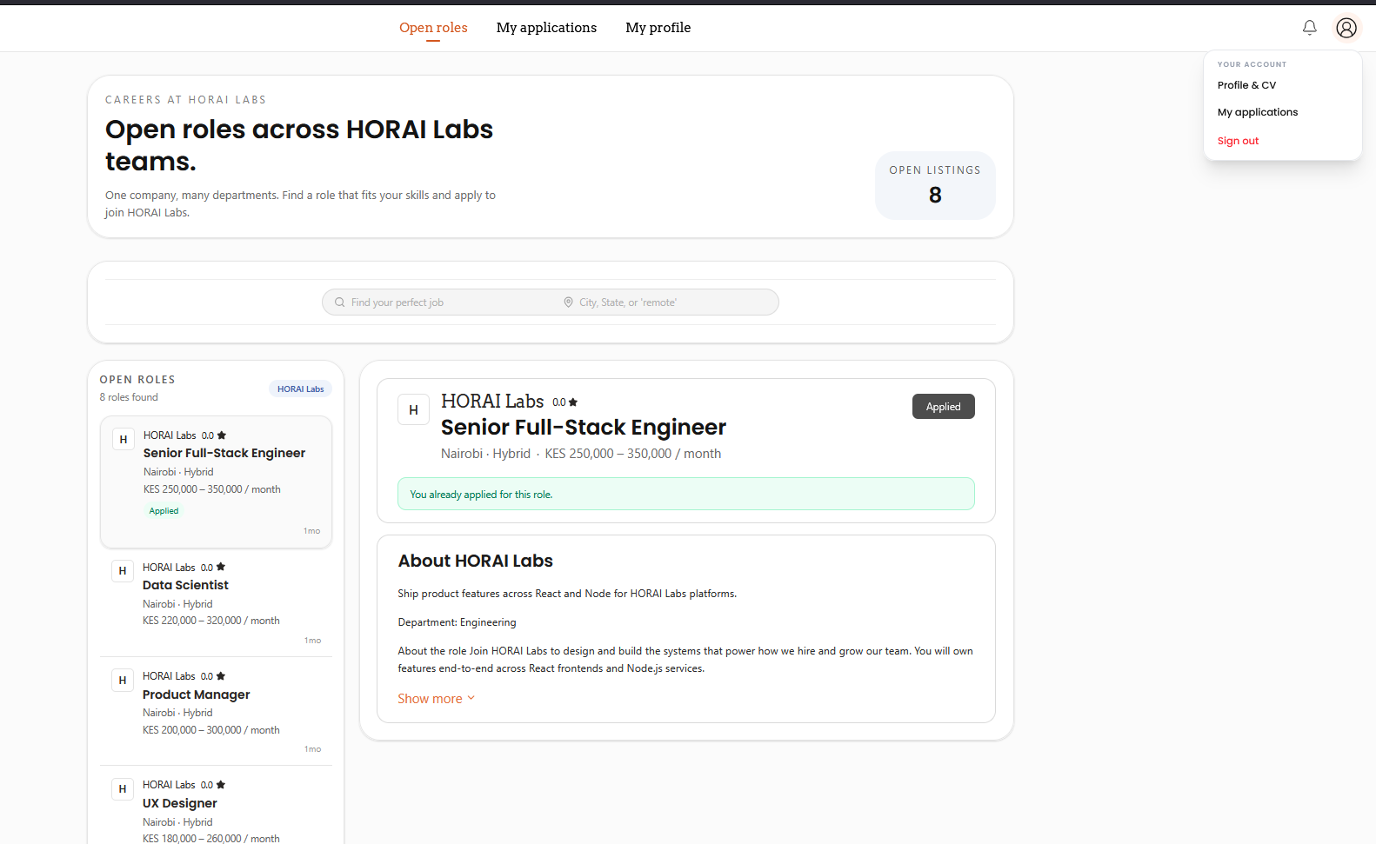

5.6.3 Resume upload page
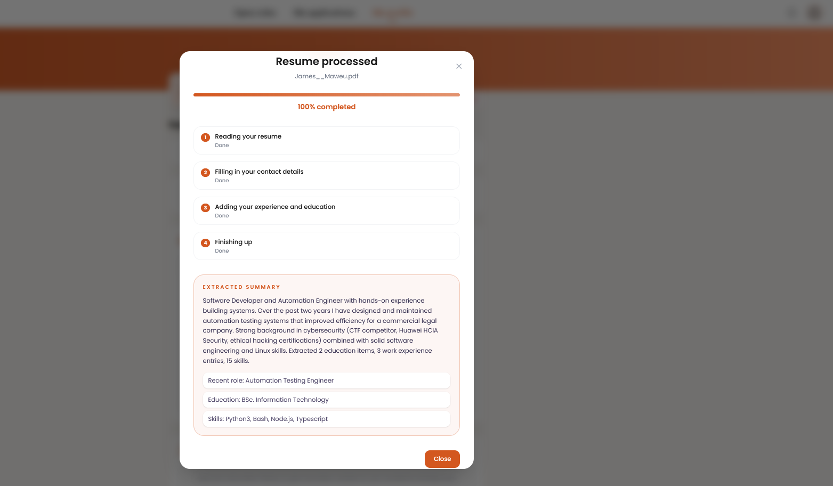

5.6.4 Job posting form
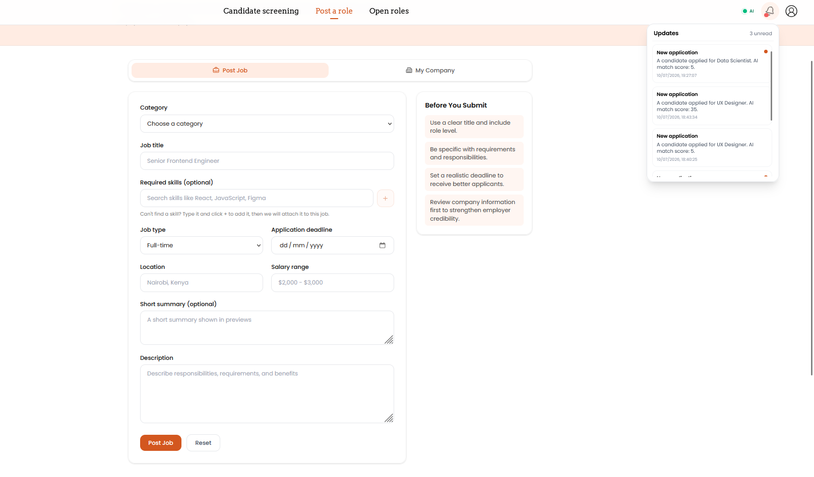

5.6.5 Admin / user management page
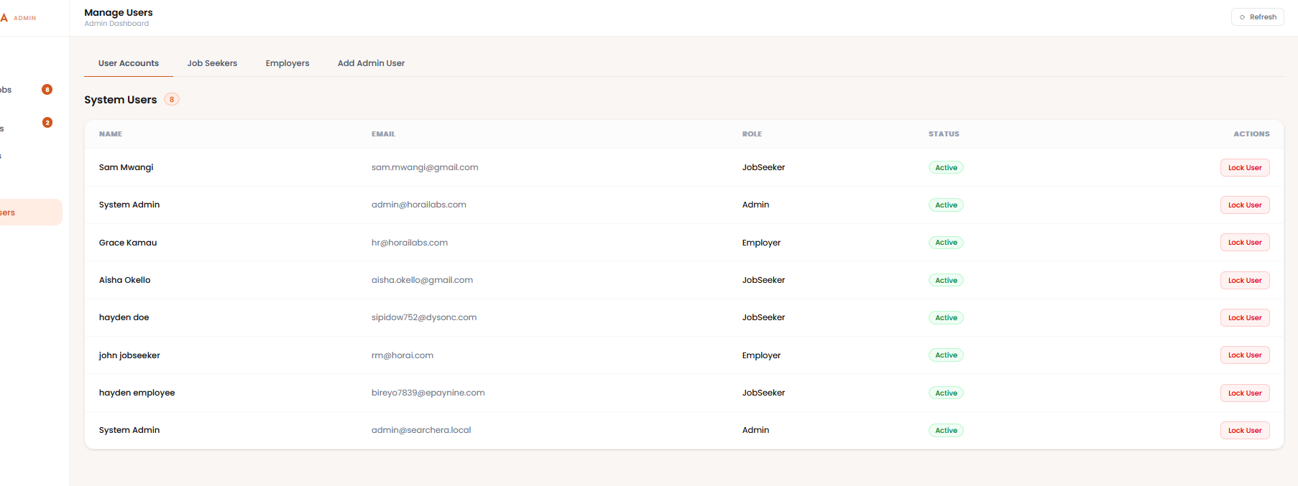

5.6.6 Reports/analytics page
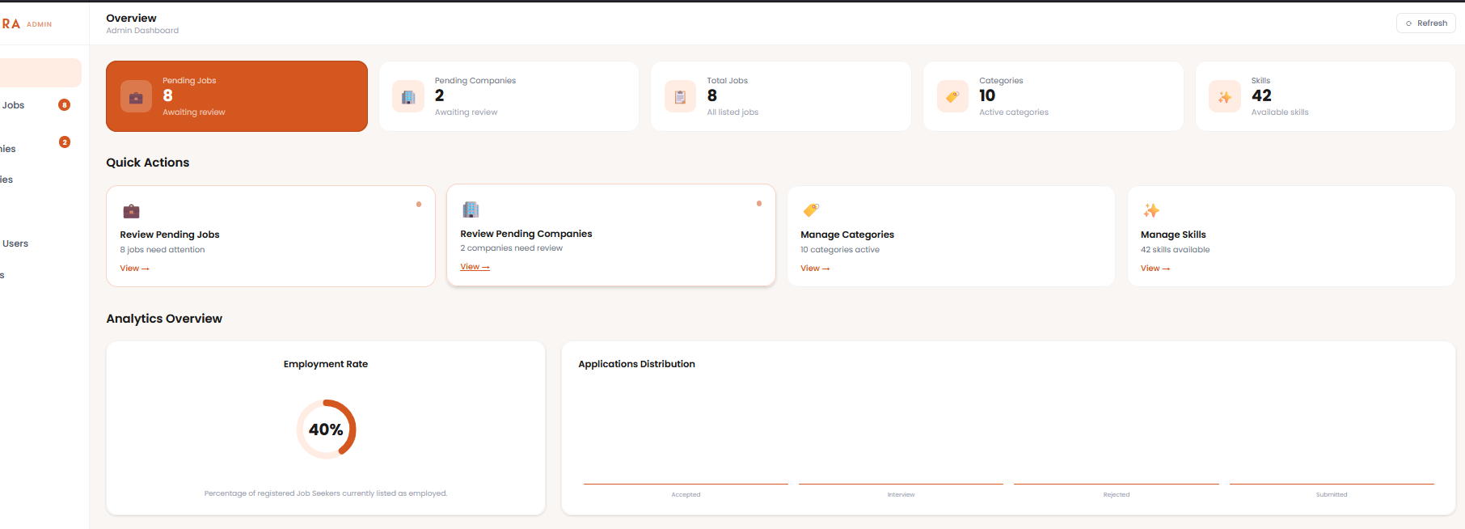

5.6.7 AI-ranked candidate shortlist
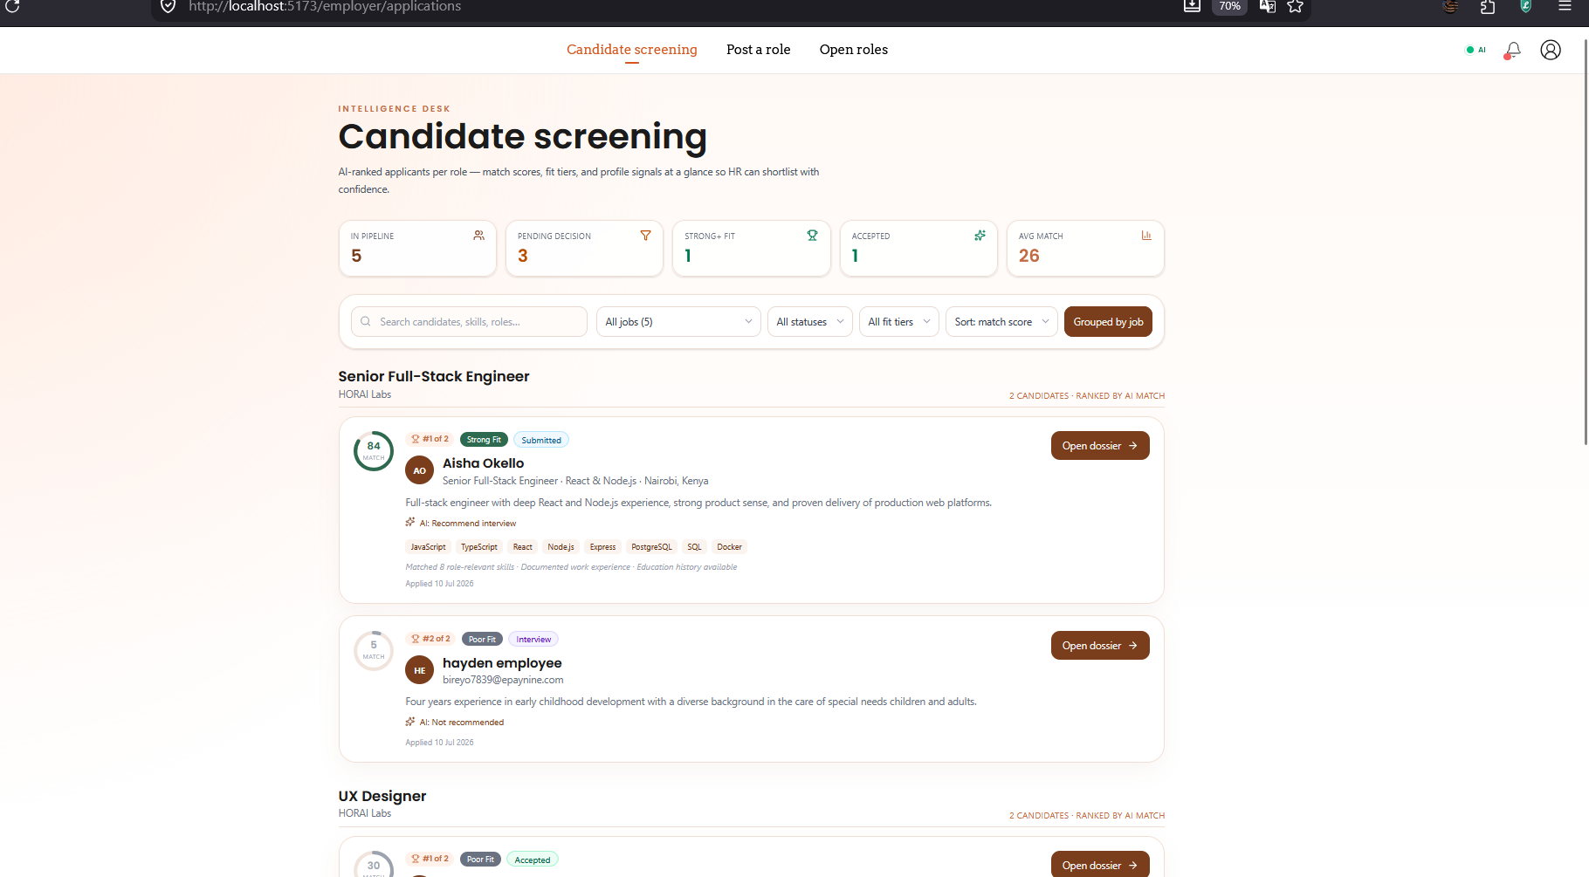

5.6.8 Explainability detail view
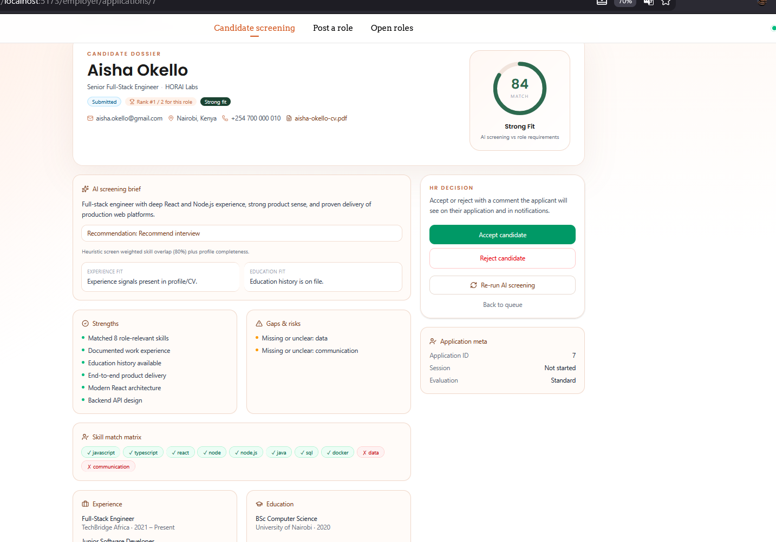

5.6.9 AI microservice JSON response
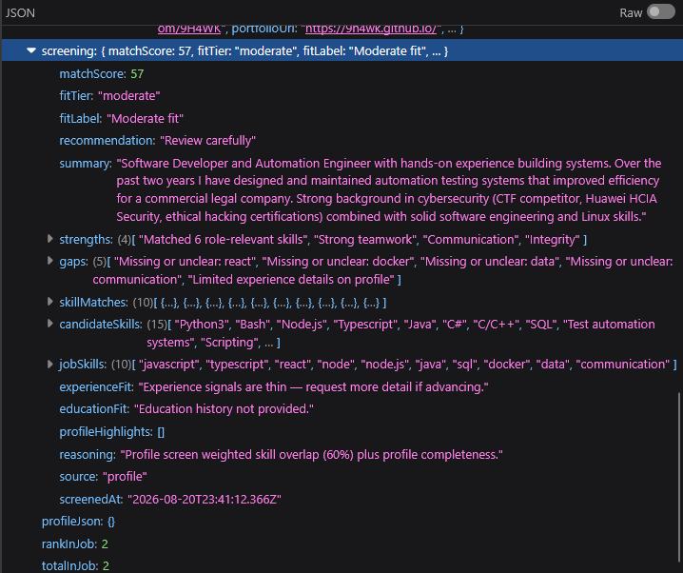

CHAPTER 6: SYSTEM REQUIREMENTS

6.1 Functional Requirements
The system must provide a comprehensive set of functional capabilities that support the entire recruitment workflow, from job posting to candidate selection. These requirements have been derived from stakeholder analysis and best practices in applicant tracking system design:
- User Account Management: The system shall allow job seekers to create, verify, and manage personal accounts, including profile creation, password management, and account recovery. Recruiters and administrators shall have distinct account types with appropriate privileges.
- Job Posting and Management: The system shall allow authorized recruiters to create, edit, publish, and close job listings. Job listings shall include fields for title, description, requirements, location, salary range, employment type, and application deadline.
- Resume Upload and Storage: The system shall allow job seekers to upload resumes in PDF, DOCX, and TXT formats. Uploaded resumes shall be securely stored and indexed for analysis.
- AI-Powered Resume Screening: The system shall automatically analyze uploaded resumes using AI and NLP techniques, extracting relevant information and comparing it against job requirements.
- Candidate Ranking: The system shall generate ranked lists of candidates based on the relevance of their qualifications to job requirements, with explainable scores and detailed breakdowns.
- Application Tracking: The system shall track the status of each application through the recruitment pipeline, with support for custom status labels and automated notifications.
- Recruiter Dashboard: The system shall provide a comprehensive dashboard for recruiters to view job postings, manage applications, review candidate rankings, and make hiring decisions.
- Communication Tools: The system shall support communication between recruiters and candidates through integrated messaging, email notifications, and interview scheduling.
- Reporting and Analytics: The system shall generate reports on recruitment metrics, including time-to-hire, source effectiveness, candidate demographics, and screening performance.
- Search and Filtering: The system shall allow recruiters to search and filter candidates based on skills, experience, education, location, and other criteria, with full-text search capabilities.

6.2 Non-Functional Requirements
In addition to the functional requirements, the system must meet a set of non-functional requirements that define how the system should perform and behave:
- Performance: The system shall process resume screening requests within 10 seconds for documents up to 10 pages. The web interface shall load within 3 seconds under normal network conditions.
- Scalability: The system shall support at least 1,000 concurrent users and 100,000 resumes without significant degradation in performance.
- Security: The system shall implement industry-standard security measures, including HTTPS encryption, secure password hashing, role-based access control, and protection against common web vulnerabilities (OWASP Top 10).
- Privacy: The system shall comply with data protection regulations, including GDPR and relevant local laws. Personal data shall be collected, processed, and stored in accordance with privacy best practices.
- Availability: The system shall achieve 99.5% uptime, with automated monitoring and alerting to detect and respond to outages.
- Usability: The system shall be intuitive and easy to use for both technical and non-technical users, with minimal training required. The interface shall comply with WCAG 2.1 Level AA accessibility standards.
- Reliability: The system shall handle errors gracefully, providing meaningful error messages to users and logging detailed information for debugging.
- Maintainability: The system shall be built using modular, well-documented code that follows established coding standards and design patterns.
- Interoperability: The system shall expose RESTful APIs that allow integration with other HR systems, job boards, and third-party services.

6.3 Hardware and Software Requirements
For development, standard workstations with at least 16GB of RAM and modern processors will be sufficient. For the AI training and inference components, access to GPU-enabled computing resources (either local or cloud-based) may be required for training large language models, though pre-trained models can be fine-tuned on CPU resources for smaller datasets.
For production deployment, the system will be hosted on cloud infrastructure with auto-scaling capabilities. The minimum production environment will include load balancers, application servers, database servers, and AI inference servers, with redundancy and failover mechanisms to ensure high availability. The specific resource allocation will be determined based on load testing results during the development phase.

CHAPTER 7: TESTING, EVALUATION, AND VALIDATION

7.1 Testing Strategy
The system will undergo comprehensive testing at multiple levels to ensure quality, reliability, and performance:
- Unit Testing: Conducted for individual components and functions using automated testing frameworks. Unit tests verify that each module performs its intended function correctly in isolation.
- Integration Testing: Verifies that the different modules of the system work together correctly, particularly the integration between the web application and the AI screening microservice. This ensures that data flows correctly between tiers and that API contracts are honored.
- System Testing: Evaluates the system as a whole against the requirements specification, covering functional requirements, non-functional requirements, and end-to-end user scenarios.
- User Acceptance Testing (UAT): Conducted with a representative group of recruiters and job seekers to validate that the system meets their needs and expectations. UAT involves structured test cases based on real-world scenarios, as well as exploratory testing that allows users to interact with the system freely and provide feedback.
- AI Model Validation: The AI screening module will be validated using a held-out test dataset of resumes and job descriptions, with performance measured in terms of accuracy, precision, recall, and F1 score compared to human expert judgments.

7.2 Data Collection and Analysis Methods
Data collection for the evaluation phase will employ multiple methods:
- System Performance Data: Collected automatically through logging and monitoring tools, capturing metrics such as screening time, response times, error rates, and system resource utilization.
- User Feedback Data: Collected through structured surveys administered to both job seekers and recruiters after they have used the system. The surveys will include Likert-scale questions for quantitative analysis and open-ended questions for qualitative insights.
- Comparative Analysis: Conducted by having recruiters screen a sample of resumes both manually and using the AI-enhanced system, then comparing the results in terms of time taken, consistency of rankings, and agreement with a gold standard established by expert consensus.
- Statistical Analysis: Performed using appropriate tests (such as t-tests for comparing means and correlation analysis for examining relationships between variables) to determine whether the differences between manual and AI-assisted screening are statistically significant.

7.3 Key Performance Indicators
The success of the system will be measured using the following Key Performance Indicators (KPIs):

Table: Key Performance Indicators
KPI / Metric | Target | Measurement Method
Screening Time Reduction | 60% decrease | Compare average screening time before and after implementation
Candidate Ranking Accuracy | 85% precision | Recruiter feedback on top-10 ranked candidates
System Uptime | 99.5% availability | Cloud monitoring dashboard and automated alerts
User Satisfaction Score | 4.0/5.0 or higher | Post-usage survey with Likert-scale questions
Resume Parsing Accuracy | 90% extraction rate | Manual verification of parsed fields against original resumes
False Positive Rate | Below 15% | Track candidates ranked highly but rejected by recruiters

7.4 Bias Monitoring and Fairness Evaluation
A critical component of the evaluation is ensuring that the AI system does not introduce or amplify biases. The project will implement ongoing bias monitoring by:
- Analyzing screening outcomes across demographic groups to detect disparities.
- Conducting regular audits of training data to identify and mitigate historical biases.
- Implementing fairness-aware machine learning techniques where appropriate.
- Providing transparent explanations for all ranking decisions to enable human oversight and correction.
Any issues discovered (e.g., biases or misparsing of resumes) will guide refinements, such as improving the NLP pipeline or normalizing input data. Usability testing will also verify that the web interface is clear and accessible, ensuring that both job seekers and recruiters can navigate the system without confusion.

CHAPTER 8: PROJECT TIMELINE AND WORK PLAN

8.1 Development Phases
The project is scheduled for completion over a 16-week period, divided into six distinct phases that correspond to the key stages of the software development life cycle:

Table: Development Phases
Phase | Key Activities | Duration
Phase 1: Analysis | Requirements gathering, stakeholder interviews, system analysis, literature review | Weeks 1-2
Phase 2: Design | System architecture design, UI/UX wireframing, database schema design, API specification | Weeks 3-4
Phase 3: Development | Frontend and backend implementation, AI/NLP module integration, database setup | Weeks 5-10
Phase 4: Testing | Unit testing, integration testing, user acceptance testing, AI model validation | Weeks 11-12
Phase 5: Deployment | Production deployment, user training, documentation, project handover | Weeks 13-14
Phase 6: Evaluation | Performance evaluation, comparative analysis, final reporting | Weeks 15-16

8.2 Detailed Sprint Schedule
Within the Development phase (Weeks 5-10), the work will be organized into two-week sprints:
- Sprint 1 (Weeks 5-6): Core backend setup, database implementation, and basic user authentication.
- Sprint 2 (Weeks 7-8): Job posting and application submission features, frontend dashboard skeleton.
- Sprint 3 (Weeks 9-10): AI microservice integration, resume upload and parsing, initial ranking algorithm.

8.3 Budget
The following budget estimate has been prepared based on a careful analysis of the resources required:

Table: Budget
Item | Category | Est. Cost (Ksh)
Personnel & Development | Development | 18,000.00
AI/NLP Integration & APIs | Development | 8,500.00
Cloud Infrastructure & Hosting | Operations | 6,000.00
Software Licenses & Tools | Tools | 3,500.00
Testing & Quality Assurance | Quality | 4,500.00
Documentation & Training | Support | 3,000.00
Contingency (10%) | Reserve | 4,350.00
Total |  | 47,850.00

CHAPTER 9: RISK ASSESSMENT
Every project involves risks that, if not properly identified and managed, can jeopardize its successful completion. The following risk matrix summarizes the key risks and their management approaches:

Table : Risk Assessment
Risk | Likelihood | Impact | Mitigation Strategy
AI model accuracy below expectations | Medium | High | Iterative model training, diverse dataset, human-in-the-loop validation
Schedule delays due to scope creep | Medium | Medium | Strict change control, weekly progress reviews, phased delivery
Data privacy and security breaches | Low | High | Encryption, access controls, GDPR compliance, regular security audits
Integration challenges with AI APIs | Medium | Medium | Prototype early, fallback mechanisms, vendor support agreements
User resistance to AI-driven screening | Medium | Medium | Change management, training sessions, transparent AI explanations
Budget overrun | Low | Medium | 10% contingency fund, monthly budget tracking, phased payment milestones
System performance under load | Medium | High | Load testing, scalable cloud architecture, caching strategies

CHAPTER 10: MONITORING AND EVALUATION PLAN

10.1 Monitoring Framework
Project progress will be monitored through regular sprint reviews, milestone assessments, and stakeholder check-ins. The project team will maintain a detailed project schedule with clearly defined milestones and deliverables for each phase. Weekly status meetings will be held to review progress, identify issues, and make adjustments as needed. A project management tool such as Jira or Trello will be used to track tasks, dependencies, and deadlines.

10.2 Evaluation Methods
Evaluation will be conducted through a combination of quantitative metrics and qualitative feedback. System performance will be evaluated using automated monitoring tools that capture metrics such as response times, throughput, error rates, and resource utilization. User satisfaction will be evaluated through structured surveys administered to both job seekers and recruiters after a period of system use. The AI screening module will be evaluated through comparative analysis with manual screening, using metrics such as precision, recall, and F1 score.
A final evaluation report will be produced at the end of the project, summarizing the findings, identifying lessons learned, and making recommendations for future improvements. This report will serve as a valuable resource for the organization and for the broader academic and professional community interested in AI-enhanced recruitment.

CHAPTER 11: EXPECTED OUTCOMES

11.1 System Deliverables
Upon completion of this project, the following tangible deliverables will be produced:
- A fully functional web-based recruitment system with integrated AI-driven resume screening capabilities, deployed and made available for use by the target organization.
- A comprehensive set of technical documentation, including system architecture diagrams, API documentation, database schema documentation, deployment guides, and maintenance manuals.
- User-oriented documentation, including user manuals for both job seekers and recruiters, quick-start guides, and frequently asked questions.
- Training materials, including video tutorials, slide decks, and hands-on exercises for system administrators and end users.

11.2 Academic and Practical Contributions
This project is expected to make several contributions to both academic knowledge and practical application. From an academic perspective, the project will provide empirical evidence regarding the effectiveness of AI-driven resume screening compared to traditional manual methods, contributing to the literature on AI applications in human resource management. The detailed documentation of the development methodology, system architecture, and evaluation results will serve as a case study that can inform future research and development efforts in this domain.
From a practical perspective, the system will provide organizations with a powerful tool for improving the efficiency, accuracy, and fairness of their recruitment processes. The reduction in screening time will free HR professionals to focus on higher-value activities such as candidate engagement and strategic workforce planning. The consistency and objectivity of AI-driven screening will support more equitable hiring practices, potentially reducing the impact of unconscious biases. The explainability features will build trust in the system and support compliance with employment regulations.

11.3 Benefits to Stakeholders
Different stakeholder groups are expected to derive distinct benefits from the successful implementation of this system:
- Job Seekers: A streamlined, user-friendly application process and the assurance that their qualifications will be evaluated objectively based on their merits rather than subjective impressions.
- Recruiters: A powerful tool for managing large volumes of applications efficiently, with AI-generated rankings that reduce the time and effort required for initial screening while improving the quality of shortlisting decisions.
- Organizations: Measurable improvements in recruitment efficiency, reduced time-to-hire, and better quality of hires. The reporting and analytics features provide visibility into recruitment metrics that support strategic decision-making and continuous improvement.
- Broader Community: Contribution to the development of more equitable and transparent hiring practices, supporting diversity and inclusion in the workforce.

CHAPTER 12: CONCLUSION AND RECOMMENDATION

12.1 CONCLUSION
This proposal has presented a comprehensive plan for the development of an AI-enhanced web-based recruitment system designed to address the critical challenges of candidate screening and selection in the digital age. The project responds to a genuine and pressing need within organizations of all sizes: the need to process large volumes of job applications efficiently, accurately, and fairly, without compromising the quality of hiring decisions or the candidate experience.
The proposed system represents a significant advancement over existing recruitment platforms by integrating the full administrative functionality of a modern applicant tracking system with sophisticated, AI-powered resume screening capabilities. By leveraging natural language processing and machine learning technologies, the system will be able to parse complex resume documents, extract relevant qualifications, and compare candidates against job requirements with a level of consistency and speed that human reviewers cannot achieve. The explainable AI features will ensure that recruiters understand and trust the system's recommendations, while the comprehensive reporting and analytics capabilities will provide valuable insights for continuous improvement.
The methodology outlined in this proposal is rigorous and systematic, combining best practices from software engineering, artificial intelligence research, and human-centered design. The mixed-methods evaluation approach will provide both quantitative evidence of system performance and qualitative insights into user experiences and perceptions. The risk assessment and monitoring framework will help ensure that the project remains on track and that potential issues are identified and addressed before they become critical.
Beyond the immediate practical benefits of improved recruitment efficiency, this project has the potential to contribute to more equitable and inclusive hiring practices. By reducing the influence of unconscious biases in the initial screening phase, the system supports a more meritocratic approach to talent selection that evaluates candidates based on their qualifications and potential rather than subjective impressions or demographic factors. While AI is not a panacea for bias, a well-designed, validated, and monitored system can be a powerful tool for promoting fairness in the workplace.
In conclusion, this project is both technically feasible and practically valuable. The proposed budget of Ksh 47,850 and the 16-week timeline are realistic and achievable given the scope and complexity of the system. The project team possesses the necessary skills and expertise to deliver the system successfully, and the stakeholder engagement plan ensures that user needs and feedback are incorporated throughout the development process. We believe that this initiative will deliver measurable value to HR teams, hiring managers, and job seekers alike, and we look forward to proceeding with the next stages of development upon approval of this proposal.

12.2 RECOMMENDATIONS
Based on the findings and the defined boundaries of this project, the following recommendations are proposed for future development and research:
- Integration with External Job Platforms: The current scope excludes integration with third-party job boards and social media networks. Future versions should incorporate API integrations with platforms such as LinkedIn, BrighterMonday, and Fuzu to widen the reach of job postings and automatically aggregate external applications into the screening pipeline.
- Resume and Credential Verification: Since screening accuracy currently depends on candidate-provided information, future work should incorporate verification mechanisms, such as automated checks against academic institutions and professional certification bodies, to validate declared qualifications.
- Advanced Candidate Assessment Features: Capabilities declared out of scope in this project, including video interviews, personality assessments, and psychometric evaluations, should be introduced in subsequent phases to provide a more holistic view of each candidate beyond textual resume data.
- Continuous Model Learning: A feedback loop should be established in which recruiter decisions, such as accepting or overriding AI recommendations, are logged and used to periodically retrain and fine-tune the matching model, thereby improving ranking accuracy over time.
- Multilingual NLP Support: The AI module currently relies on English text-based data. Future research should extend the NLP pipeline to support additional languages, such as Swahili, to accommodate a broader and more inclusive candidate pool.
- Strengthened Bias Auditing: While the system implements ongoing bias monitoring, future iterations should adopt more advanced fairness-aware machine learning techniques and periodic independent audits to ensure compliance with the Data Protection Act (2019) and emerging regulations on algorithmic accountability in hiring.
- Mobile Application: Given the high mobile internet penetration in the region, a companion mobile application with push notifications for application status updates should be developed to improve accessibility for job seekers.
- Predictive Analytics: Future versions should leverage historical hiring data to predict candidate success, retention likelihood, and time-to-hire trends, supporting more strategic workforce planning for organizations.

REFERENCES
- Barber, A. E. (1998). Recruiting employees: Individual and organizational perspectives. Thousand Oaks, CA: SAGE Publications.
- Breaugh, J. A. (2017). To use or not to use technology: That is the question. In H. W. Goldstein, E. D. Pulakos, J. Passmore, & C. Semedo (Eds.), The Wiley Blackwell handbook of the psychology of recruitment, selection and employee retention (pp. 123-145). Wiley Blackwell.
- Dastin, J. (2018). Amazon scraps secret AI recruiting tool that showed bias against women. Reuters. https://www.reuters.com/article/world/insight-amazon-scraps-secret-ai-recruiting-tool-that-showed-bias-against-women-idUSKCN1MK0AG/
- Gus Dorf, M. L. (2008). Recruitment and selection: Hiring the right person. Society for Human Resource Management.
- Parry, E., & Tyson, S. (2008). An analysis of the use and success of online recruitment methods in the UK. Human Resource Management Journal, 18(3), 257-274. https://doi.org/10.1111/j.1748-8583.2008.00070.x
- Raghavendra, S. (2019). Artificial intelligence in human resources: A review of the literature and future directions. International Journal of Human Resource Management, 30(6), 1008-1032.
- Singh, R., & Sharma, A. (2020). Machine learning approaches for resume screening: A systematic review. International Journal of Information Management, 54, 102-115.
- Tambe, P., Cappelli, P., & Yakubovich, V. (2019). Artificial intelligence in human resources management: Challenges and a path forward. California Management Review, 61(4), 15-42.
- Vaswani, A., Shazeer, N., Parmar, N., Uszkoreit, J., Jones, L., Gomez, A. N., Kaiser, L., & Polosukhin, I. (2017). Attention is all you need. Advances in Neural Information Processing Systems, 30, 5998-6008.
- Zhang, L., & Li, X. (2021). Natural language processing in resume parsing: Techniques and challenges. Journal of Computer Science and Technology, 36(4), 789-805.

APPENDICES
Appendix I: Sample Code
## Snippet 1 - Semantic Candidate - Job Matching with Explainable Output

Real code, trimmed from api/services/screening.js. The deterministic scorer
weights skill overlap (75%) plus profile completeness; every result carries
per-requirement evidence (skillMatches), human-readable strengths / gaps
and a reasoning trace. When a provider key is configured, aiScreenCandidate
re-scored the same fields via the LLM and the heuristic result is used verbatim
as the offline fallback (screenApplication).

javascript
// Snippet 2 — real code: api/services/screening.js (trimmed).
// Explainable rank bands used verbatim by the recruiter UI shortlist.

const FIT_TIERS = [
{ min: 85, tier: "excellent", label: "Excellent fit", recommendation: "Strongly recommend" },
{ min: 70, tier: "strong", label: "Strong fit", recommendation: "Recommend interview" },
{ min: 55, tier: "moderate", label: "Moderate fit", recommendation: "Review carefully" },
{ min: 40, tier: "weak", label: "Weak fit", recommendation: "Likely pass" },
{ min: 0, tier: "poor", label: "Poor fit", recommendation: "Not recommended" },
];

export function tierFromScore(score) {
const n = Number(score) || 0;
return FIT_TIERS.find((t) => n >= t.min) || FIT_TIERS[FIT_TIERS.length - 1];
}

// Keyword lookup doubles as an NER stand-in when the LLM is offline.
function extractJobSkills(job = {}) {
const text = [job.title, job.description, job.summary, job.category]
.filter(Boolean).join(" ");
const known = [ /* trimmed: the file lists 30+ terms e.g. javascript, react,
python, aws, docker, tableau, communication, agile */ ];
return uniqueSkills(known.filter((skill) => text.toLowerCase().includes(skill)));
}

export function computeHeuristicScreening({ job, profile, cvAnalysis }) {
const jobSkills = extractJobSkills(job);
const candidateSkills = extractCandidateSkills(profile, cvAnalysis);
const candidateSet = new Set(candidateSkills.map(normalizeSkill));

// Per-requirement evidence: {skill, matched} — the explainability bedrock.
const skillMatches = jobSkills.map((skill) => ({
skill,
matched: candidateSet.has(skill) ||
[...candidateSet].some((c) => c.includes(skill) || skill.includes(c)),
source: candidateSet.has(skill) ? "profile/cv" : "job requirement",
}));

const matchedCount = skillMatches.filter((s) => s.matched).length;
const skillScore = jobSkills.length
? Math.round((matchedCount / Math.max(jobSkills.length, 1)) * 100)
: Math.min(70, candidateSkills.length * 8);

// Completeness bonus rewards documented experience/education/summary fields.
const hasExperience = /* profile or CV experience array non-empty */;
const profileBonus = [hasExperience, hasEducation, hasHeadline, hasBio]
.filter(Boolean).length * 4;

const matchScore = Math.max(5, Math.min(98,
Math.round(skillScore * 0.75 + profileBonus + (candidateSkills.length > 0 ? 8 : 0))));

return {
matchScore,
fitTier: tierFromScore(matchScore).tier,
fitLabel: tierFromScore(matchScore).label,
recommendation: tierFromScore(matchScore).recommendation,
summary: cvAnalysis?.summary || profile.bio || ${profile.firstName || "Candidate"}
shows a ${tierLabel.toLowerCase()} for ${job.title || "this role"} ...,
strengths: [ /* "Matched 5 role-relevant skills", "Documented work experience", ... */ ],
gaps: skillMatches.filter((s) => !s.matched)
.map((s) => Missing or unclear: ${s.skill}).slice(0, 5),
skillMatches, // met / not-met matrix rendered in the UI
reasoning: Profile screen weighted skill overlap (${skillScore}%) plus profile completeness.,
source: "profile", // safe label, never exposes the vendor
screenedAt: new Date().toISOString(),
};
}

## Snippet 2 - Database Schema
Status: **adapted / generated for PostgreSQL**. The shipped MVP creates the same
tables in SQLite via sql.js (api/db.js), which is why the production columns
are preserved verbatim below (SQLite AUTOINCREMENT → SERIAL, REAL →
NUMERIC). screening_results is a **proposed normalisation**: today the
explanation JSON, score and tier are stored as columns *inside* applications
(screening_json, match_score, fit_tier), so extracting a results table is a
refactor rather than current behaviour.

sql
-- Snippet 4 — PostgreSQL DDL: real columns from api/db.js, PostgreSQL-syntax.
-- GENERATED adaptation + normative screening_results table (see header note).

CREATE TABLE users (
id SERIAL PRIMARY KEY,
email TEXT UNIQUE NOT NULL,
password_hash TEXT NOT NULL, -- bcrypt (cost 10), never plaintext
role TEXT NOT NULL DEFAULT 'JobSeeker' -- JobSeeker | Employer | Admin
CHECK (role IN ('JobSeeker', 'Employer', 'Admin')),
profile_json TEXT, -- skills/experience/education payload
user_name TEXT, first_name TEXT, last_name TEXT, phone TEXT,
bio TEXT, linkedin_url TEXT, github_url TEXT, portfolio_url TEXT,
location TEXT, headline TEXT,
created_at TIMESTAMPTZ NOT NULL DEFAULT now()
);

CREATE TABLE jobs (
id SERIAL PRIMARY KEY,
company_id INTEGER REFERENCES companies(id) ON DELETE CASCADE,
title TEXT NOT NULL,
description TEXT, summary TEXT,
job_type TEXT, salary_range TEXT, location TEXT, deadline TEXT, category TEXT,
created_at TIMESTAMPTZ NOT NULL DEFAULT now()
);

CREATE TABLE applications ( -- one seeker per job
id SERIAL PRIMARY KEY,
user_id INTEGER NOT NULL REFERENCES users(id) ON DELETE CASCADE,
job_id INTEGER NOT NULL REFERENCES jobs(id) ON DELETE CASCADE,
status TEXT NOT NULL DEFAULT 'Submitted', -- Submitted|Interview|Accepted|Rejected
hr_comment TEXT, -- visible to the applicant
screening_json TEXT, -- full explainable payload (MVP storage)
match_score NUMERIC(5,2), -- 0-100 composite score
fit_tier TEXT, -- excellent|strong|moderate|weak|poor
decided_at TIMESTAMPTZ,
created_at TIMESTAMPTZ NOT NULL DEFAULT now(),
UNIQUE (user_id, job_id)
);

CREATE TABLE resumes ( -- "cvs" in the MVP schema
id SERIAL PRIMARY KEY,
user_id INTEGER NOT NULL REFERENCES users(id) ON DELETE CASCADE,
file_path TEXT, -- uploads/cvs/<uuid>.pdf (10 MB cap)
file_name TEXT,
analysis_json TEXT, -- LLM/heuristic extraction result
created_at TIMESTAMPTZ NOT NULL DEFAULT now()
);

-- PROPOSED normalisation of the screening output (not yet extracted in the MVP).
CREATE TABLE screening_results (
id SERIAL PRIMARY KEY,
application_id INTEGER NOT NULL REFERENCES applications(id) ON DELETE CASCADE,
match_score NUMERIC(5,2) NOT NULL,
fit_tier TEXT NOT NULL,
requirement_json TEXT NOT NULL, -- [{skill, matched}] matrix
strengths_json TEXT, -- human-readable evidence
gaps_json TEXT, -- missing requirements
reasoning TEXT, -- free-text explanation trace
source TEXT NOT NULL DEFAULT 'profile', -- 'profile' | 'assisted'
screened_at TIMESTAMPTZ NOT NULL DEFAULT now(),
UNIQUE (application_id, screened_at) -- full re-screen audit trail
);

CREATE INDEX idx_applications_job_score
ON applications (job_id, match_score DESC); -- serves the ranked shortlist

